

**Car repair center project**

**Alpha X Team**

**Abstract**

This project contains many innovative solutions to solve the problem of technical malfunctions in cars, which usually occur repeatedly, and to help their owners overcome this by creating a web application Through it, the owner can reach the nearest and best repair point for his car.

**Acknowledgment**

We would like to thank everyone who helped us carry out this project, and we especially thank our senior professors and faculty members, in addition to our family and friends.

Table of Contents

Chapter 1 3

Introduction 4

Problem Statement 5

Propose solution 6

Requirement Analysis 7

Chapter 2 10

Related Work 11

Features 11

UI and UX 12

Pros and Cons 12

Chapter 3 13

Introduction 14

Context Diagram 15

Data Flow Diagram 16

Possible IT Strengths 16

Possible IT Weaknesses 17

Possible IT Opportunities 17

Possible IT Threats 19

Chapter 4 20

# 

# Chapter 1

## Introduction

In the ever-evolving landscape of the automotive industry, the digital transformation has ushered in new opportunities and challenges for car owners and automotive repair centers alike. As car ownership becomes more prevalent, the need for efficient and effective communication between vehicle owners and repair centers is paramount. This report aims to identify and address the key problems and challenges associated with a website that serves as an intermediary between car owners seeking repair and the repair centers providing services.

The website in question plays a crucial role as a mediator between car owners and repair centers, facilitating the connection and interaction between these two parties. However, several challenges and issues have emerged, which necessitate a comprehensive analysis and potential solutions.

## Problem Statement

In an era where digital technology revolutionizes the automotive industry, the relationship between car owners and repair centers is undergoing a significant transformation. The proliferation of websites designed to mediate these interactions holds immense potential for streamlining and enhancing the process of car maintenance and repair. However, this evolving landscape is not without its challenges, which necessitate comprehensive analysis and innovative solutions.

Several pressing issues are observed within the domain of websites mediating between car owners and repair centers:

**Limited User Engagement:** Many of these websites suffer from low user engagement and conversion rates, failing to effectively guide users toward selecting repair services and facilitating successful interactions. The lack of engagement raises questions about the overall efficiency of these platforms.

**Inadequate Information Availability:** Car owners often struggle to find comprehensive and up-to-date information about available repair services, pricing, location details, and the qualifications of repair technicians. This information gap hinders informed decision-making, thereby impacting the user experience.

**Complex User Interface:** The user interfaces of many of these websites are not optimized for ease of use. Complex navigation, cluttered layouts, and unintuitive search functionalities contribute to user frustration

**Mobile Responsiveness**: With the increasing trend of users accessing the internet via mobile devices, the lack of mobile responsiveness is a significant concern. Suboptimal mobile experiences can lead to reduced user satisfaction and missed opportunities.

**Ineffective SEO Strategy:** The websites often struggle with search engine optimization (SEO), resulting in low visibility on search engine result pages. Inadequate SEO strategies limit the websites' reach and accessibility to car owners and repair centers, affecting their ability to connect users effectively.

These challenges are at the core of our investigation. Addressing these issues is essential to improve the effectiveness of websites that mediate between car owners seeking repair services and repair centers. Our report will delve into a thorough analysis, identifying the root causes of these problems, and propose practical solutions to enhance the functionality and user experience of such websites. By doing so, we aim to contribute to a more efficient and user-centric digital platform for both car owners and repair centers.

## Propose solution

1. Improving User Engagement:

* User-Friendly Interface: Redesign the website's user interface to make it more intuitive and user-friendly. Simplify navigation, use clear calls to action, and ensure that the user journey is smooth and engaging.
* Incentives and Rewards: Implement a rewards program or discounts for users who book appointments through the platform. This can encourage more users to convert and engage with repair centers.
* Streamlined Booking Process: Simplify the service request and appointment booking process to reduce friction and make it easier for users to access repair services.

1. Enhancing Information Availability:

* Comprehensive Database: Create and maintain a comprehensive database of repair centers, including details about services offered, pricing, technician qualifications, and customer reviews. Encourage repair centers to regularly update their profiles.
* User-Generated Content: Encourage car owners to leave reviews and ratings for repair centers, providing valuable information for other users and enhancing the credibility of the platform.
* Integration with Repair Centers: Provide repair centers with user-friendly tools and incentives to keep their profiles up-to-date, ensuring that accurate information is readily available to users.

1. User-Friendly User Interface:

* Responsive Design: Invest in responsive web design to ensure that the website performs well on various devices and screen sizes, including mobile phones and tablets.
* Intuitive Navigation: Revamp the navigation and user interface to make it more intuitive. Implement user testing to gather feedback and make improvements based on user preferences.
* Streamlined Search: Optimize the search functionality, allowing users to easily find repair centers based on location, services offered, or other relevant criteria.

1. Mobile Optimization:

* Responsive Design: Ensure that the website is fully responsive and optimized for mobile devices. This includes adjusting layouts, buttons, and interactions to provide an excellent mobile user experience.
* Mobile App: Consider developing a dedicated mobile app to provide a tailored experience for users on smartphones and tablets. Apps can offer additional features and convenience.

1. SEO Optimization:

* Keyword Optimization: Identify and optimize keywords relevant to the automotive repair industry to improve the website's search engine rankings.
* Quality Content: Develop high-quality, informative content related to car repair and maintenance to increase the website's authority and relevance to search engines.
* Backlink Building: Implement a backlink-building strategy to improve the website's credibility and authority, which can positively impact its search engine rankings.

These proposed solutions aim to address the identified problems and enhance the functionality and user experience of the website that mediates between car owners and repair centers. By implementing these changes, the website can become a more efficient and user-centric platform, facilitating better interactions and connections between car owners and repair centers, ultimately benefiting both parties.

## Requirement Analysis

1. Stakeholder Requirements:

* Car Owners: Identify the needs and expectations of car owners using the website. This could include finding repair services, comparing service providers, accessing pricing information, and booking appointments.
* Repair Centers: Determine the requirements of repair centers, such as maintaining accurate profiles, receiving appointment requests, and managing customer feedback.
* Administrators: Understand the requirements of website administrators responsible for overseeing and maintaining the platform, including user management, content moderation, and system maintenance.

1. Functional Requirements:

* User Registration and Profiles: Define the requirements for user registration, profile creation, and user management, including account verification and password reset functionality.
* Search and Matchmaking: Specify the search criteria, filtering options, and matchmaking algorithms used to connect car owners with repair centers.
* Communication Tools: Describe the communication features like direct messaging, appointment scheduling, and notifications.
* Data Security: Identify the security requirements for protecting user data, personal information, and payment details.
* Database Management: Define the requirements for storing and managing data related to repair centers, services, and user interactions.
* Mobile Responsiveness: Specify the requirements for ensuring the website is fully responsive and functions effectively on various devices and screen sizes.

1. Non-Functional Requirements:

* Performance: Define performance requirements, including response time, page load speed, and server uptime.
* Scalability: Determine how the website should handle increased user traffic and data growth over time.
* SEO Optimization: Specify requirements for optimizing the website's search engine visibility, keyword usage, and content quality.
* Usability: Establish usability requirements, such as user interface design, user testing, and user feedback collection.
* Security: Define security requirements for protecting user data, implementing encryption, and preventing data breaches.
* Compliance: Ensure that the website complies with relevant data protection regulations and legal requirements.

1. Data Requirements:

* Data Collection: Specify the data that needs to be collected from car owners, repair centers, and administrators. This includes user profiles, service information, reviews, and communication logs.
* Data Storage: Determine the data storage requirements, including the type of database and its structure.
* Data Analytics: Identify the data analytics requirements for generating insights, reports, and performance metrics.

1. User Experience Requirements:

* User-Friendly Interface: Define requirements for a user-friendly and intuitive interface, including layout, navigation, and design elements.
* Mobile Experience: Specify requirements for optimizing the mobile user experience, such as responsive design and mobile app development.
* User Training: If necessary, outline requirements for user training and onboarding to ensure users can effectively use the platform.

1. Maintenance and Support Requirements:

* System Updates: Specify requirements for periodic system updates and improvements.
* Customer Support: Define requirements for customer support channels and response times.
* Issue Resolution: Determine the process and requirements for addressing user issues and complaints.
* Documentation: Outline the need for user guides, help documentation, and FAQs.

Ensure that your requirement analysis is comprehensive, addressing all aspects of the project. This analysis will serve as a foundation for the development and implementation of the website that mediates between car owners and repair centers, and it will guide your report's recommendations and findings.

# Chapter 2

## Related Work

There are a number of car repair center web apps available, but most of them offer similar features. Some of the most popular car repair center web apps include:

1. Your Mechanic
2. Carvana
3. Fixd
4. Mechanic Advisor
5. Repair Pal

## 

## Features

Here are some of the key features of our car repair center web app:

* Virtual car inspection: Customers will be able to use their smartphone to take a video of their car's exterior and interior, and then submit it to the car repair center for a virtual inspection. The mechanic will then review the video and provide the customer with an estimate for the repairs needed.
* Real-time repair updates: Customers will be able to use the web app to track the progress of their car repairs in real time. They will be able to see what repairs have been completed, what repairs are currently in progress, and what estimated time of completion is for the entire job.
* Interactive repair guide: The web app will include an interactive repair guide that customers can use to learn how to perform basic car repairs themselves. The guide will include step-by-step instructions, videos, and diagrams.
* Community forum: The web app will include a community forum where customers can ask questions about their cars, share tips and advice, and get help from other customers and mechanics.
* Gamification: The web app will incorporate gamification elements to make it more fun and engaging for customers. For example, customers could earn points for completing car repairs, reading the repair guide, and participating in the community forum. Points could then be redeemed for discounts on repairs or other rewards.

## UI and UX

The web app will have a clean and modern design that is easy to navigate. Users will be able to easily find the information they need and schedule appointments with just a few clicks.

The web app will be responsive, so it will look good and function well on all devices, including smartphones, tablets, and laptops.

## Pros and Cons

**Pros:**

* Convenience: Customers can schedule appointments and track the progress of their repairs online.
* Efficiency: Virtual car inspections and real-time repair updates save customer’s time.
* Expertise: Customers can get help from experienced mechanics and other customers.
* Fun and engaging: Gamification elements make the web app more fun and rewarding to use.

**Cons:**

* May require some upfront investment to develop and maintain the web app.
* May be challenging to integrate the web app with existing car repair center systems.

Overall, our car repair center web app will be a valuable tool for customers and car repair centers alike. It will offer a variety of innovative features that make it convenient, efficient, and engaging to use.

# Chapter 3

## Introduction

A context diagram provides a high-level overview of the interactions between a system and its external entities. In the case of a car repair website, a context diagram visually represents the relationships and connections between the website and its various stakeholders, such as customers, mechanics, and other relevant entities. It serves as a valuable tool for understanding the scope and boundaries of the system, as well as the flow of information and interactions within it. The car repair website is an innovative platform designed to facilitate the process of vehicle maintenance and repair for both car owners and automotive professionals. It leverages the power of the internet to connect customers in need of repair services with qualified mechanics and service providers. By offering a centralized hub for car repair needs, the website aims to streamline the process, enhance convenience, and improve overall customer experience. The context diagram for the car repair website illustrates the system as a single entity surrounded by its external entities. These external entities can include users accessing the website through different devices, service providers offering their expertise, third-party payment gateways, and any other relevant systems or stakeholders involved in the car repair process. The diagram highlights the interactions, data flows, and dependencies between the website and these external entities, providing a clear and concise representation of the system's context. By examining the context diagram, stakeholders can gain insights into how the car repair website functions within its broader environment. They can understand how information is exchanged, what entities are responsible for specific tasks, and how the system interfaces with external systems or services. This understanding is crucial for developing and maintaining a successful car repair website, as it allows for effective communication, collaboration, and coordination between all parties involved.

In summary, a context diagram for a car repair website offers a visual representation of the system's relationships with its external entities. It serves as a valuable tool for understanding the scope, boundaries, and interactions within the website, enabling efficient communication and efficient functioning of the platform.

## DFD

## Context Diagram

1. The user requests a service from the car workshop.
2. The user's device receives a push notification informing them that their service request has been sent to the management center system.
3. The management center system reviews the service request and either accepts or refuses it.
4. Depending on the decision of the management center system, the user's device receives a push notification. If the request was accepted, the notification will inform the user that their service request has been accepted. If the request was refused, the notification will inform the user that their service request has been refused.
5. If the service request was accepted, the management center system can then coordinate with the car workshop to schedule the service.

## Level 0

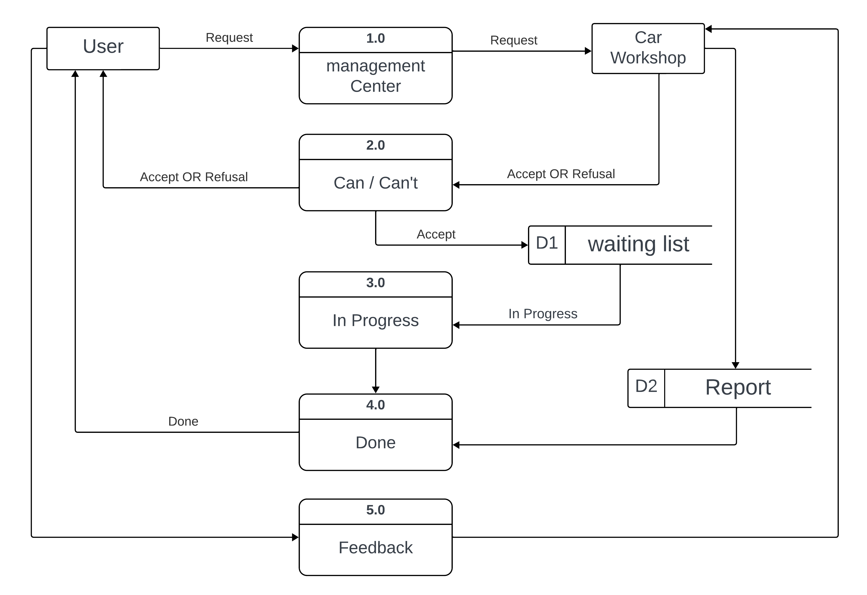

## Possible IT Strengths

1. Ability to design and develop user-friendly interfaces and intuitive navigation for websites and mobile apps. This includes skills like responsive web design, usability testing and improvement.
2. Skills in database design, development and management. This allows creating and maintaining comprehensive databases of repair centers and related information.
3. Capabilities in incentivizing and rewarding users through discounts, points etc. to drive engagement. Requires integration of such features into the website/app.
4. Optimization skills - SEO, website performance optimization, search optimization to enhance discoverability and user experience.
5. Integration capabilities to provide tools and incentives for repair centers to update their profiles and information. Requires API/systems integration skills.
6. Mobile optimization skills to make the platform seamless across devices. Includes responsive design, mobile app development capability.
7. Ability to leverage user-generated content like ratings and reviews to enhance credibility and user experience. Requires building such features into the platform.
8. Backlink building skills to improve search rankings and traffic through off-page optimization and partnerships.

In summary, the key IT strengths demonstrated are: user interface design, database management, incentivization techniques, optimization skills, integration skills, mobile expertise, UGC features, and SEO/backlink capabilities. Highlighting these in a capabilities overview can showcase the team's technical expertise in building user-centric digital platforms.

## Possible IT Weaknesses

1. Data security and protection of users' personal information.
2. Compliance with data protection laws and regulations.
3. System performance and quick response.
4. Ability to withstand increased user traffic and amount of data over time.
5. Improve the interface and design it to be easy to use.
6. The design is responsive to mobile devices and different sizes.
7. Search engine optimization (SEO) strategy.
8. The ability to update and develop the system periodically.
9. Customer support and quick response to problems.
10. Documenting the system and training users on it.

## Possible IT Opportunities

1. Website Development:

The development of the website itself is a significant IT opportunity. This involves designing and building the website's frontend and backend, implementing user registration and login systems, search and filtering functionalities, and integrating with external APIs for services like geolocation and mapping.

1. Database Management:

Establishing and managing a robust database is crucial for storing and retrieving information about repair centers, including their location, contact details, services offered, and customer reviews. IT professionals can develop and optimize the database architecture, ensure data integrity, and implement efficient querying mechanisms.

1. Integration with APIs:

Integrating with external APIs can enhance the functionality of the website. For example, integrating with geolocation services like Google Maps API or Mapbox can provide accurate location-based services and mapping functionalities. Additionally, integrating with payment gateways, automotive databases, or diagnostic tools can further enhance the user experience.

1. Data Security and Privacy:

Ensuring data security and privacy is of utmost importance when dealing with user information and transactions. IT professionals can implement robust security measures, such as encryption, secure sockets layer (SSL) certificates, and compliance with data protection regulations like GDPR or CCPA

1. User Experience (UX) Design:

UX design plays a crucial role in creating a user-friendly and intuitive website. IT professionals with expertise in UX design can optimize the user interface, navigation flow, and information architecture to ensure a seamless and engaging user experience.

1. Performance Optimization:

Optimizing the website's performance is essential to provide a smooth and responsive user experience. IT professionals can employ techniques such as caching, load balancing, image optimization, and code optimization to improve page load times and overall performance.

1. Analytics and Reporting:

Implementing analytics tools and generating reports can provide valuable insights into user behavior, popular search queries, and repair center performance. IT professionals can set up analytics platforms like Google Analytics and develop custom reporting functionalities to track and analyze key metrics.

1. Continuous Improvement and Maintenance:

IT opportunities also include ongoing maintenance, bug fixes, and feature enhancements based on user feedback and market trends. IT professionals can monitor the website's performance, address technical issues, and implement updates to ensure a smooth and up-to-date user experience.

1. Integration with Third-Party Systems:

To provide a comprehensive solution, IT professionals can explore opportunities to integrate the website with third-party systems such as automotive diagnostic tools or inventory management systems. This integration can streamline processes and provide additional functionalities for both car owners and repair centers.

These IT opportunities can help ensure the successful development, implementation, and ongoing improvement

## Possible IT Threats

1. Security Breaches:

One of the significant threats is the risk of security breaches, such as unauthorized access to user data, hacking attempts, or data leaks. This can lead to compromised user information, financial loss, reputation damage, and legal consequences.

1. Data Privacy Concerns:

Collecting and storing user data raises privacy concerns. Failure to comply with data protection regulations or mishandling of sensitive information can result in legal and reputational risks

1. Malicious Attacks:

The website may be vulnerable to various types of malicious attacks, including Distributed Denial of Service (DDoS) attacks, SQL injections, cross-site scripting (XSS), or malware infections. These attacks can disrupt the website's functionality, compromise data, or lead to unauthorized access.

1. Phishing and Social Engineering:

Car owners and repair centers may be targeted by phishing attempts or social engineering attacks. Attackers may impersonate the website or send fraudulent emails to deceive users into disclosing sensitive information or performing malicious actions.

1. Lack of Regular Security Patching and Updates:

Failing to apply security patches and updates promptly can leave the website and its underlying software vulnerable to known exploits and vulnerabilities.

To mitigate these threats, it is essential to implement robust security measures, such as strong authentication mechanisms, encryption, network security, regular security audits, and employee training on cybersecurity best practices. Additionally, conducting regular vulnerability assessments, staying updated with security patches, and having incident response plans in place can help minimize risks and protect the website and its users from potential IT threats.

**Methodology**

**Prototyping**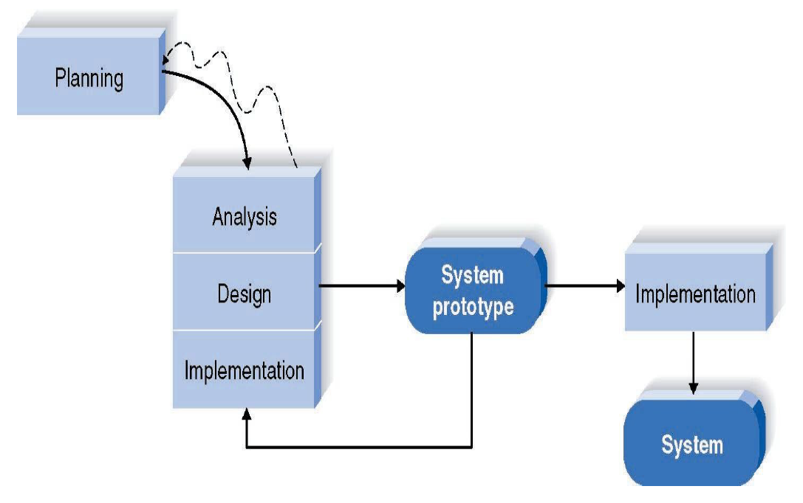

# Chapter 4



